1. What is Scalability?
Definition:
Scalability refers to a system's ability to handle increased workload or expand its capacity without compromising performance, reliability, or efficiency.

Key Characteristics:
- Horizontal Scaling: Adding more nodes/devices (e.g., cloud servers).
- Vertical Scaling: Upgrading existing hardware (e.g., CPU/RAM).
- Elasticity: Dynamic scaling based on demand (common in cloud computing).

Authoritative Sources:
- IEEE: "Scalability in Distributed Systems" (IEEE Xplore)
- ACM: "Principles of Scalable Systems" (ACM Digital Library)
- IETF RFC 3724: "Scalability Considerations for IoT"

2. Scalability in Computing and IoT
In Computing:
- Cloud Computing: AWS/Azure auto-scaling for variable workloads.
- Databases: Sharding (MongoDB) or replication (PostgreSQL).

In IoT:
- Device Scalability: Supporting thousands of sensors (e.g., smart cities).
- Network Scalability: Protocols like MQTT, CoAP for low-overhead communication.
- Data Scalability: Edge computing to reduce cloud dependency.

Why It Matters for IoT:
- Massive Device Growth: 50B+ IoT devices by 2030 (Statista).
- Real-Time Processing: Latency-critical apps (e.g., autonomous vehicles).
- Resource Constraints: Limited power/budget in edge devices.
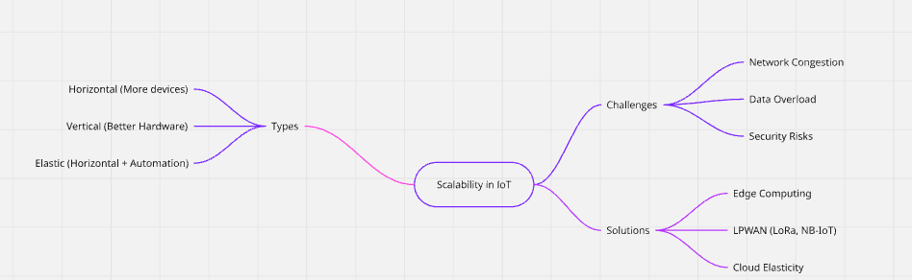
Picture 1 – A mindmap show the relation of information related to Scalability in IoT.

Sources:
- IEEE IoT Journal: "Scalability Challenges in IoT Networks"
- IETF RFC 7228: "Terminology for Constrained-Node Networks"
- ACM Transactions on IoT: "Edge Computing for Scalable IoT"

